

**Assignment No: 1**

**NAME: IZAZ UR RAHMAN**

**REG NO: 21MDSWE170**

**SUBJECT: ARTIFICIAL INTILIGENCE**

**SEMESTER: 5TH**

**BATCH: 4TH**

**SUBMITTED TO: ENGR FAHIM ULLAH**

**Assignment:**

Consider the game tree below in which the first player is trying to maximize his score and the number at the leaves are the values returned by a static evaluator for the board positions reached.

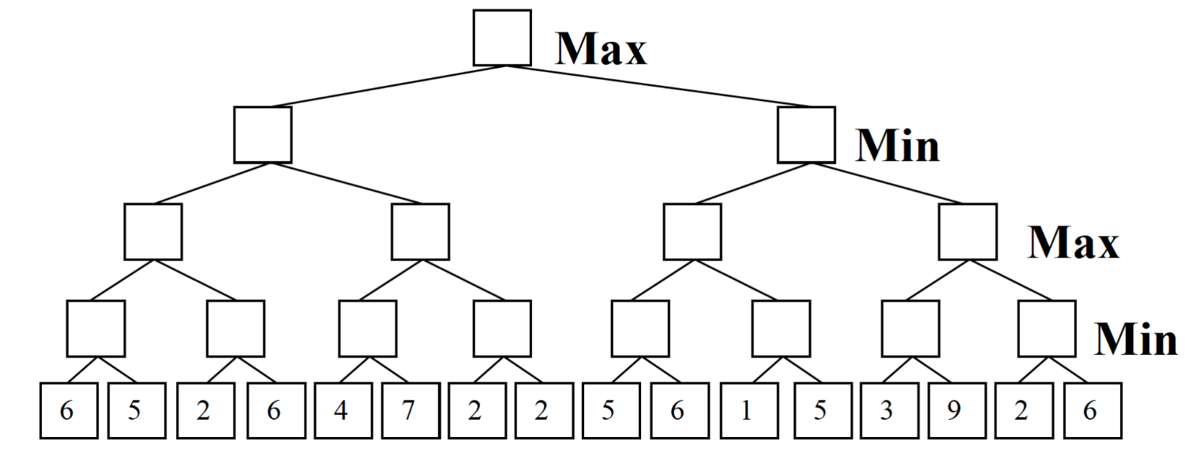

1. Fill in each box with the value returned by the standard minimax algorithm.
2. Circle the best initial move for the first player: left right.
3. In the copy of this game tree below, fill in each box with the value returned by the standard alpha beta algorithm if the tree is processed from left to right. Cross out both leaves and non-leaf nodes that need not be examined or considered.

**********************

Ans: a). Fill in each box with the value returned by the standard minimax algorithm.

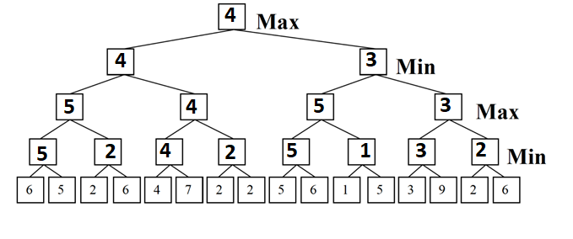

Ans: b) Circle the best initial move for the first player: left right.



Ans: c) In the copy of this game tree below, fill in each box with the value returned by the standard alpha beta algorithm if the tree is processed from left to right. Cross out both leaves and non-leaf nodes that need not be examined or considered.

